State Machine Features

Version 1.0

Contents

Pre-Requisites: 3

CMS Dashboard 3

Start up and Initialization in State Machine: 4

State Machine start-up: 4

State Machine initialization 6

State Machine initialization on power failure 9

Viewing the alarms 12

Clearing and acknowledging the alarms 14

Alarm clearing 14

Alarm Acknowledging: 16

Changing state in CMS: 16

Monitoring Parameter out of range Alarms: 18

Configuring Rules 19

Exception Handling 19

# Pre-Requisites:

Following are the pre-requisites for state machine features:

1. All cms configurations as mentioned in CMS Configuration and Deployment [NCRA] document should be done.

# CMS Dashboard

To view the dashboard login into CMS with user who has expert permission can see the Dashboard tab. The Dashboard displays the following:

1. Dashboard shows the current state of the CMS, and other sub system states, expert can change the CMS state by selecting the state and clicking on apply button. The dashboard screenshot is displayed below:

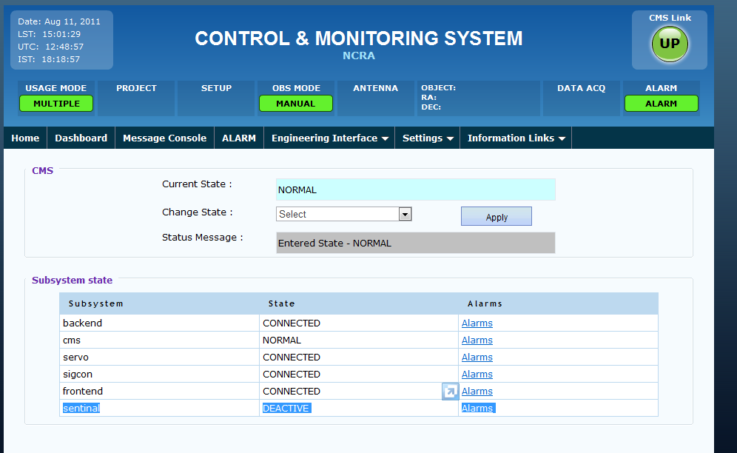

1. The Status Message displays the cms state change information. When state change is in progress it will display the transition in progress message. When the state transition is in progress user is not allowed to change the state.
2. Deactivated sub system status is displayed as DEACTIVE as shown in above screenshot.

# Start up and Initialization in State Machine:

### State Machine start-up:

When CMS is started it is always enters the START state and the CMS functions as mentioned below.

1. CMS checks the wrapper connectivity for configurable amount of time if wrapper is not connected than CMs raises the wrapper down alarms, and move into SUSPEND state – refer below figure

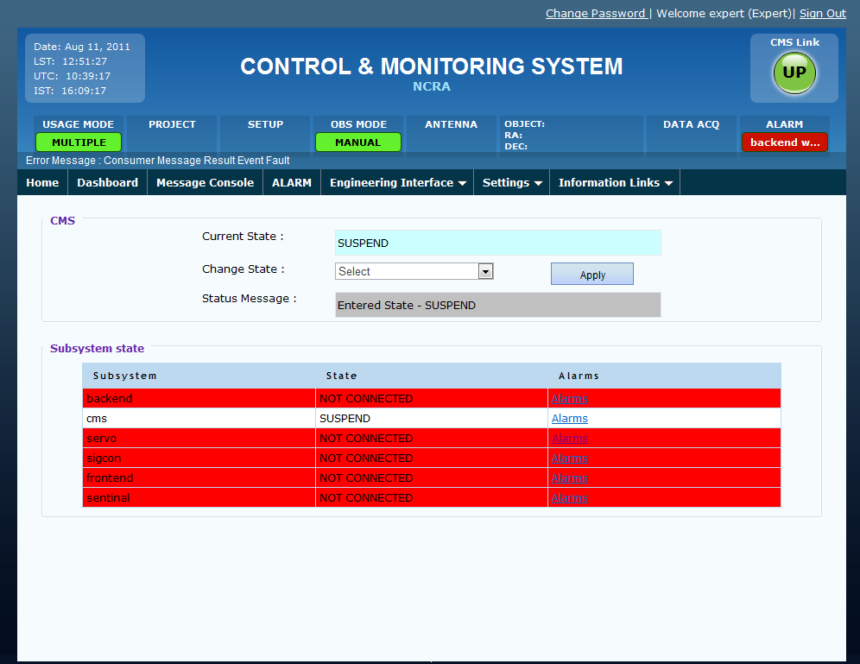

1. To view the alarm for the particular subsystem click on the alarm link. Refer below figure for the servo sub system

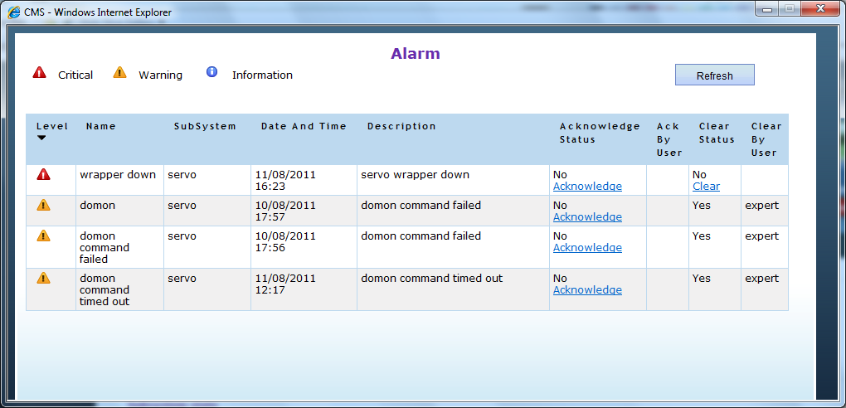

### State Machine initialization

1. If previously CMS was SHUTDOWN properly and wrappers are connected then CMs moves to INIT state and execute the all sub system initialization script “initAllSubsystems.txt”.

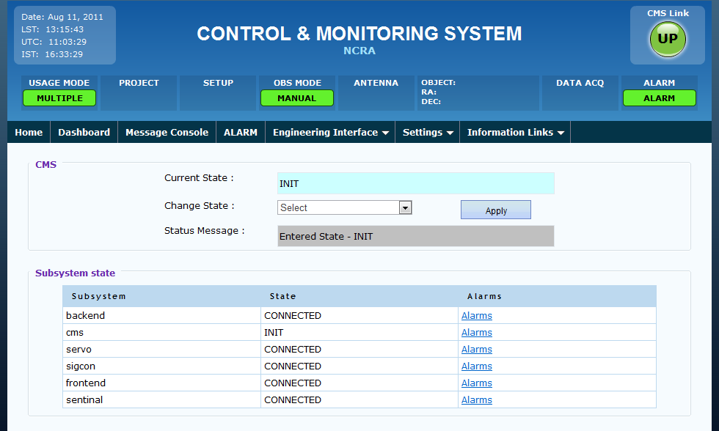

1. After successfully completion of the INIT state CMS moves into NORMAL state as displayed below:

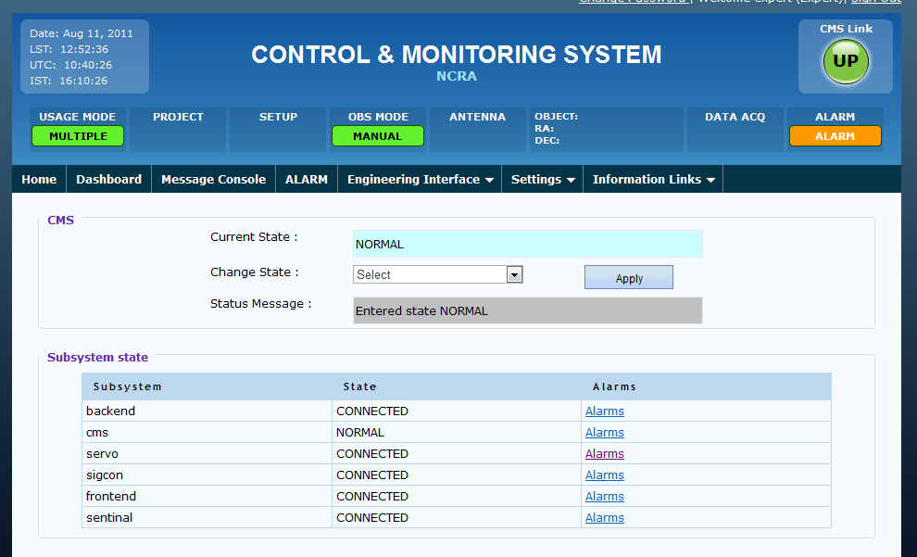

1. If initialization is not successful than CMS raises the initialization fail alarm as show below and moves to SUSPEND state.

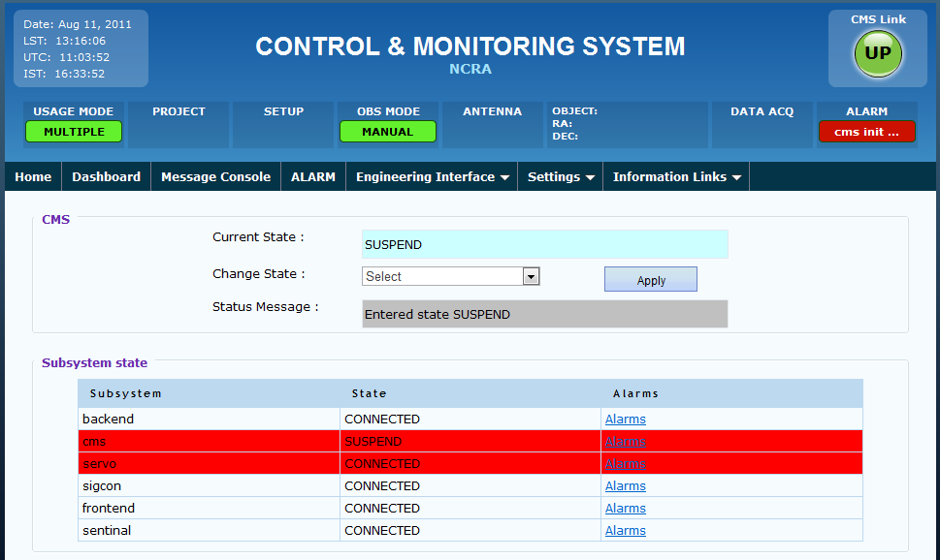

1. Click on the alarms link to view the alarm raised for the particular subsytem.

### State Machine initialization on power failure

1. If previously CMS was not SHUTDOWN properly and wrappers get connected after CMS start-up then CMs moves to INIT_ON_POWERFAILURE state as shown in below screenshot. In this state CMS executes all the sub system restore scripts as specified in “init_on_powerfailure.txt” batch script.

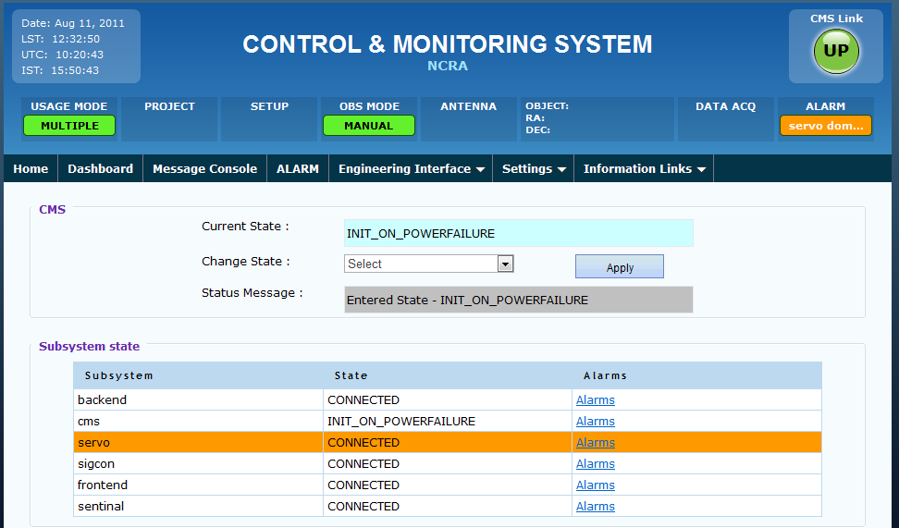

1. If CMS couldn’t restore the sub system than CMS raises the alarm for initialization failure and then moves into SUSPEND state.



1. If CMS either successfully completed INIT or INIT_ON_POWERFAILURE than CMS move into NORMAL state and no alarms are shown.



# Viewing the alarms

To view the recent raised alarms go to Dashboard Tab

1. Dashboard shows the current state of the CMS, and other sub system states, along with alarms link, depending on the alarm severity and level background color of subsystem is changed.
2. Click on alarm links show sub system specific alarms details and their severity level along with color.

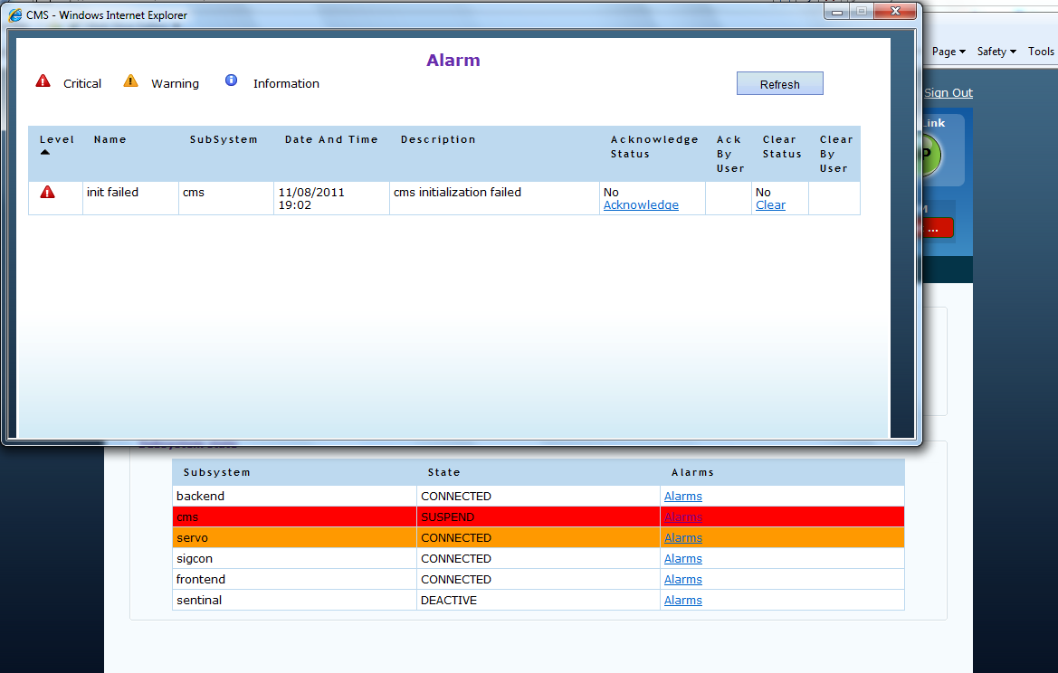

1. Alarms levels as below
   1. If alarm level 5 then background is shown in red color
   2. If alarm level equals 3 or4 then background shown in orange color
   3. If alarm level equals 1 or 2 then background shown in yellow color

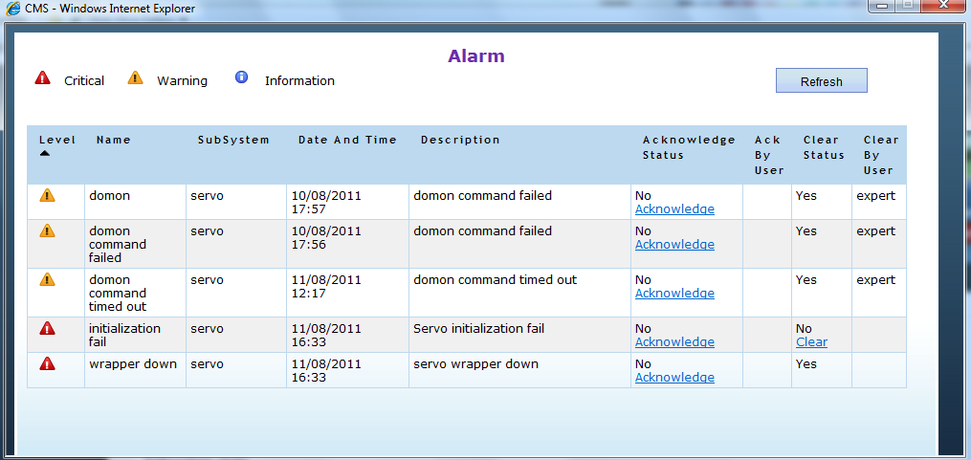

# Clearing and acknowledging the alarms

### Alarm clearing

1. When user clear the alarm it will ask for the conformation to clear the alarm if user selects ok the alarm get cleared and background color changes for the particular subsystem, and user name is updated in clear by user column.

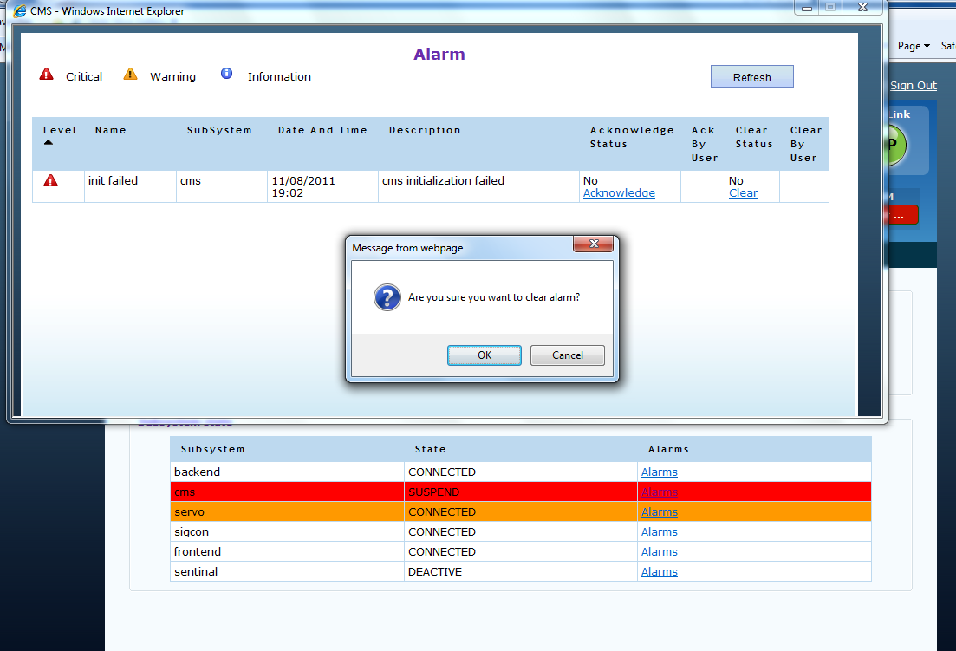

1. After clearing the CMS alarm CMS look like as below,

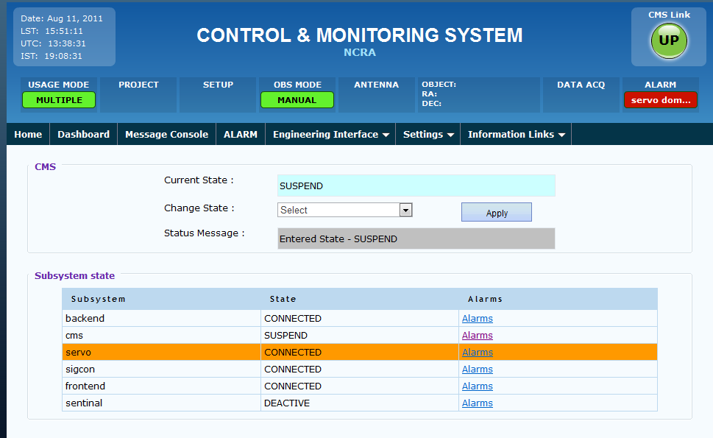

### Alarm Acknowledging:

When user clicks on Acknowledge link on the recent alarm page the alarm gets acknowledge and the user name of the user who acknowledged the alarm appear on the page.

# Changing state in CMS:

1. List of the CMS states are as displayed below.

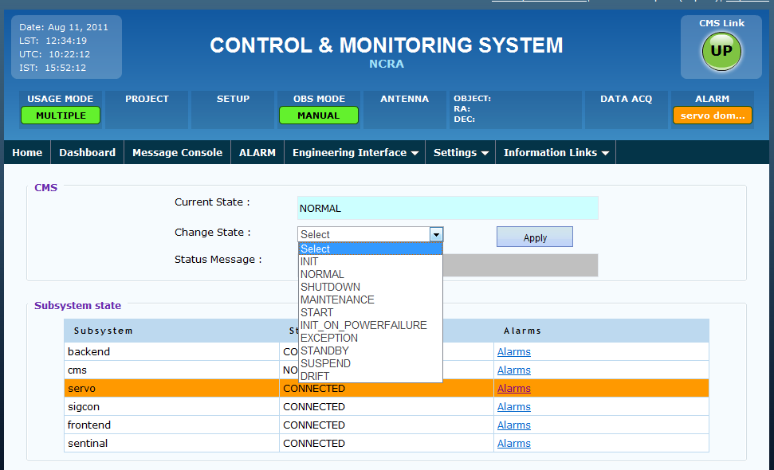

1. To change the state select the State and click on apply button. Then CMS will try to transition to the selected state, right now following transitions are supported.

Transition_NORMAL_TO_SHUTDOWN"

Transition_INIT_TO_NORMAL"

Transition_INIT_TO_MAINTENANCE"

Transition_INIT_ON_POWERFAILURE_TO_MAINTENANCE"

Transition_INIT_TO_SHUTDOWN"

Transition_INIT_ON_POWERFAILURE_TO_SHUTDOWN"

Transition_INIT_TO_EXCEPTION"

Transition_INIT_ON_POWERFAILURE_TO_EXCEPTION"

Transition_NORMAL_TO_MAINTENANCE"

Transition_START_TO_INIT"

Transition_START_TO_INIT_ON_POWERFAILURE"

Transition_INIT_ON_POWERFAILURE_TO_NORMAL"

Transition_INIT_ON_POWERFAILURE_TO_SUSPEND"

Transition_INIT_IN_PROGRESS"

Transition_MAINTENANCE_IN_PROGRESS"

Transition_NORMAL_IN_PROGRESS"

Transition_INIT_ON_POWERFAILURE_IN_PROGRESS"

Transition_NORMAL_TO_EXCEPTION"

Transition_EXCEPTION_TO_NORMAL"

Transition_EXCEPTION_TO_SHUTDOWN"

Transition_MAINTENANCE_TO_SHUTDOWN"

Transition_MAINTENANCE_TO_NORMAL"

Transition_NORMAL_TO_STANDBY"

Transition_STANDBY_TO_NORMAL"

Transition_STANDBY_TO_SHUTDOWN"

Transition_SUSPEND_IN_PROGRESS"

Transition_NORMAL_TO_SUSPEND"

Transition_SUSPEND_TO_NORMAL"

Transition_SUSPEND_TO_SHUTDOWN"

Transition_SUSPEND_TO_MAINTENANCE"

Transition_SUSPEND_TO_EXCEPTION"

Transition_EXCEPTION_TO_SUSPEND"

Transition_EXCEPTION_TO_STANDBY"

Transition_STANDBY_TO_EXCEPTION"

Transition_INIT_TO_SUSPEND"

Transition_SUSPEND_TO_INIT"

Transition_SUSPEND_TO_INIT_ON_POWERFAILURE"

Transition_NORMAL_TO_DRIFT"

Transition_DRIFT_TO_NORMAL"

Transition_SUSPEND_TO_DRIFT"

Transition_DRIFT_TO_SUSPEND"

1. If CMS is moved to INIT or INIT_ON_POWERFAILURE state than CMS again executes the initialization script or restore script and raises the alarm as mention in State Machine Initialization section.
2. If CMS is moved to SHUTDOWN state the state-machine thread end and no other state-change happens. In future on SHUTDOWM tomcat server will also be shutdown. And for CMS and state-machine to be up a tomcat restart will be required.

# Monitoring Parameter out of range Alarms:

Monitoring Param out of range alarm would be raised whenever a monitoring parameter goes out of range.

Alarms for various subsystems would be displayed in various colors depending upon the level of alarms raised for that particular subsystem.

Alarms that are configured for Monitoring Parameter out of range will only be raised. The alarm configuration is mentioned in the CMS Configuration and Deployment [NCRA] document. The alarm name and the monitoring param name should be same for the alarm to raised.

For example: “**Wind velocities out of limit**” alarm would be raised whenever wind velocity reaches out of limit as shown below.

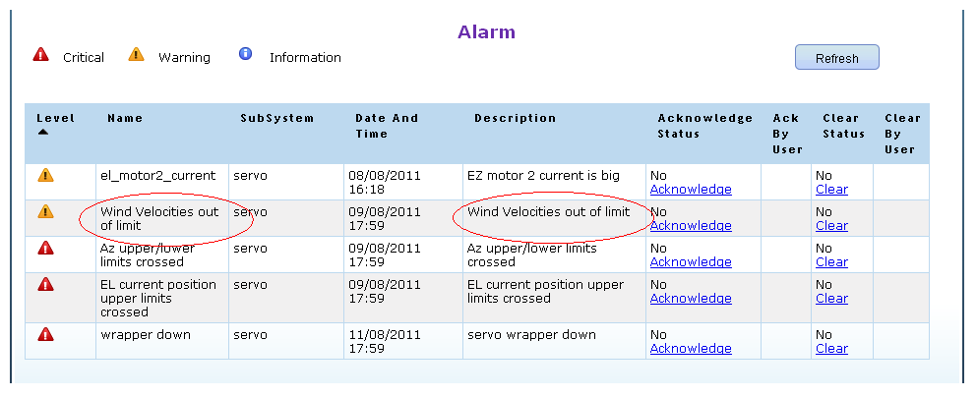

# Configuring Rules

This feature will be available in the future release.

# Exception Handling

This feature will be available in the future release.